**GITAM School of Technology Hyderabad Campus**

**Branch/Semester: B.Tech /6th Sem**

**Subject Title: Software Engineering Lab Task 2**

**Note:**

* Don’t Paste the Paragraph
* Include the content in Point wise Only
* Font Type/ Font Size- Bookman Old Style (14)
* Justify the Content
* Line Spacing: 1.5
* Two Screens Per Page.
* Include Four Sided Border
* Include a Water Mark for the Entire Document your Pin No
* Do Submission within the time

**write any program is goggle colab using hard coding variables, keyboard input, read from a file single input and read from a file multiple set of inputs and save all the versions, debug and fix any errors , push all the versions into your git hub account**

Create a Google Colab notebook that demonstrates all the required tasks:

**Steps:**

1. **Hardcoding Variables**: Demonstrate by using predefined values.
2. **Keyboard Input**: Use Python's input() to accept data from the user.
3. **Read From File (Single Input)**: Read a single input from a file.
4. **Read From File (Multiple Inputs)**: Read multiple inputs from a file and process them.
5. **Save All Versions**: Save each version of the program in different cells/files.
6. **Debug and Fix Errors**: Handle errors like missing files, incorrect input, etc.
7. **Push Versions to GitHub**: You can use git commands within Colab (assuming the repository is already initialized).

**Complete Program in Google Colab:**

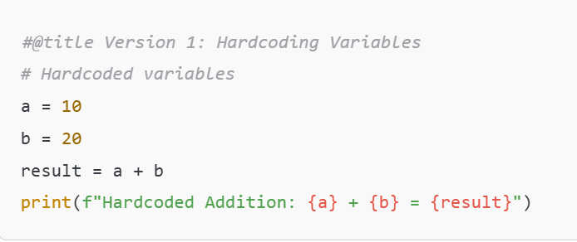

**Step 1: Set Up GitHub Repository**

1. Go to your GitHub account.
2. Create a new repository.
   * Click on the + icon in the top right corner and select **New Repository**.
   * Give the repository a name (e.g., ColabPrograms).
   * Make it public or private as per your requirement.
   * Do not initialize with a README file.
3. Copy the repository URL (e.g., https://github.com/YourGitHubUsername/ColabPrograms.git).

**Step 2: Connect Google Colab to Google Drive**

In Google Colab, run this code to mount your Google Drive: